- Starting from Grant Details (Grant Management>All Grants>Click on applicable Grant Name)
- Click Post-Award>Management>Amendments
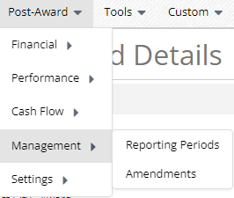

- Click the plus icon in the upper right-hand corner


- Enter Amendment Request Name and check Budget under Areas to Amend
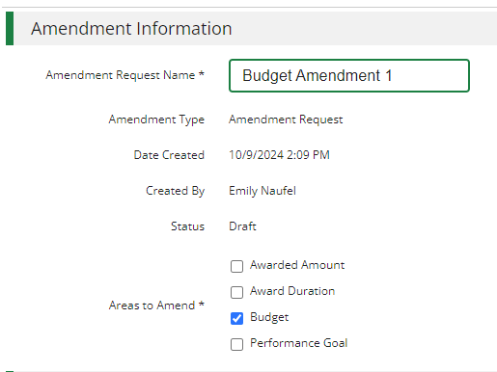

- Click Download Budget
This is an AmpliFund generated budget spreadsheet. It pulls the current AmpliFund budget into a spreadsheet and all changes that you intend to make must be made on this spreadsheet. The updated spreadsheet is then uploaded to AmpliFund in step 9 below to make the Summary of Proposed Changes correctly display for step 11.
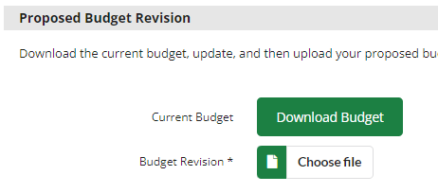

- Open the excel file (it will display in the upper right-hand corner of your browser to open)
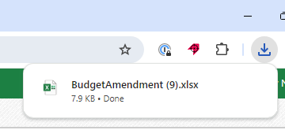

- Adjust the AmpliFund generated budget Excel file using the instructions below.
For Illinois Community College Board Grants:
Use the following instructions to make changes to existing budget category lines. Remember, expenditures must be entered at the total budget category level, consistent with the Section A tab of the Uniform Budget Spreadsheet.
- For changes to Personnel, Fringe Benefits, and Consultant:
Enter the new proposed amount in the Salary, Grant Budgeted, and Total Budgeted (Direct Cost) columns. This must be the total you intend the entire category to be after the modification. Do not change any other columns.
- For changes to Training and Education, Other or Miscellaneous Costs, Travel, Equipment, Supplies, and Contractual Services:
Enter the new proposed amount in the Cost Rate, Grant Budgeted, and Total Budgeted (Direct Cost) columns. This must be the total you intend the entire category to be after the modification. Do not change any other columns.
- For changes to Indirect Cost:
Enter the new proposed amount in the Base, Grant Budgeted, and Total Budgeted (Direct Cost) columns. This must be the total you intend the entire category to be after the modification. Do not change any other columns.
Use the following instructions to add new budget category lines. Remember, expenditures must be entered at the total budget category level, consistent with the Section A tab of the Uniform Budget Spreadsheet.
Enter the required information listed in the table below in the first blank under the existing lines. The first blank line should have a drop down to select items in the Line Item Type and Calculation Type columns. To add additional lines, you will need to insert a line to ensure you get the drop down in the Line Item Type and Calculation Type columns, or you can use the small green square in the Line Item and Line Item Type Column to drag the information down into new lines
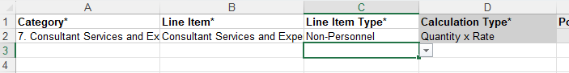

The table below provides the specific details that you will need to enter for expenditure categories. Enter the Category name exactly as listed next to Category (including the number, period, and space) to ensure the line item properly aligns to the AmpliFund budget:
Personnel (Salaries and Wages) | Fringe Benefits | Travel
Category: 1. Personnel (Salaries and Wages)  Line Item: Personnel  Line Item Type: Direct Cost Calculation  Base: Enter the total of your Personnel category  Calculation Type: Select “Quantity x Rate”  Rate: 1%  Cost Rate: Enter the total for your Personnel category  Quantity: 1  Salary: Enter the total for your Personnel category  Grant Budgeted: Enter the total for your Personnel category | Category: 2. Fringe Benefits  Line Item: Fringe Benefits  Line Item Type: Direct Cost Calculation  Base: Enter the total of your Fringe Benefits category  Calculation Type: Select “Quantity x Rate”  Rate: 1%  Cost Rate: Enter the total for your Fringe Benefits category  Quantity: 1  Salary: Enter the total for your Fringe Benefits category  Grant Budgeted: Enter the total for your Fringe Benefits category | Category: 3. Travel  Line Item: Travel  Line Item Type: Direct Cost Calculation  Calculation Type: Select “Quantity x Rate”  Rate: 1%  Cost Rate: Enter the total for your Travel category  Quantity: 1  Grant Budgeted: Enter the total for your Travel category
Equipment | Supplies | Contractual Services & Subawards
Category: 4. Equipment  Line Item: Equipment  Line Item Type: Direct Cost Calculation  Calculation Type: Quantity x Rate  Rate: 1%  Cost Rate: Enter the total for your Equipment category  Quantity: 1  Grant Budgeted: Enter the total for your Equipment category | Category: 5. Supplies  Line Item: Supplies  Line Item Type: Direct Cost Calculation  Calculation Type: Quantity x Rate  Rate: 1%  Cost Rate: Enter the total for your Supplies category  Quantity: 1  Grant Budgeted: Enter the total for your Supplies category | Category: 6. Contractual Services & Subawards  Line Item: Contractual Services  Line Item Type: Direct Cost Calculation  Calculation Type: Quantity x Rate  Rate: 1%  Cost Rate: Enter the total for your Contractual Services category  Quantity: 1  Grant Budgeted: Enter the total for your Contractual Services category
Consultant Services and Expenses | Training and Education | Other or Miscellaneous Costs
Category: 7. Consultant Services and Expenses  Line Item: Consultant Services and Expenses  Line Item Type: Direct Cost Calculation  Calculation Type: Quantity x Rate  Base: Enter the total for your Consultant Services category  Rate: 1%  Cost Rate: Enter the total for your Consultant Services category  Quantity: 1  Salary: Enter the total of your Consultant Services category  Grant Budgeted: Enter the total for your Consultant Services category | Category: 12. Training and Education  Line Item: Training and Education  Line Item Type: Direct Cost Calculation  Calculation Type: Quantity x Rate  Rate: 1%  Cost Rate: Enter the total for your Training and Education category  Quantity: 1  Grant Budgeted: Enter the total for your Training and Education category | Category: 14. Other or Miscellaneous Costs  Line Item: Other or Miscellaneous Costs  Line Item Type: Direct Cost Calculation  Calculation Type: Quantity x Rate  Rate: 1%  Cost Rate: Enter the total for your Other or Miscellaneous Costs category  Quantity: 1  Grant Budgeted: Enter the total for your Other or Miscellaneous Costs category
Indirect Cost
Category: Indirect Cost
Line Item: Indirect Cost
Line Item Type: Indirect Cost
Calculation Type: Quantity x Rate
Rate: 1%
Cost Rate: Enter the total for your Consultant Services category
Quantity: 1
Grant Budgeted: Enter the total for your Consultant Services category
Important File Reminders:
- Do not change the column headers text
- Do not delete the columns identified with an *
- Actuals columns are for reference only and changing in the spreadsheet will not result in any changes in AmpliFund
- Save the File
- Upload saved version of the AmpliFund generated budget. Remember, if the revised AmpliFund generated budget is not uploaded here or if the document is completed incorrectly, the Summary of Proposed Changes section will be incorrect.
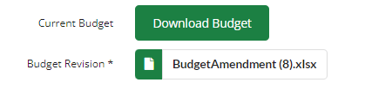

- Add Summary of Changes Narrative. This should be a brief summary of changes, as a full and detailed justification of the changes is required in step 12 below.
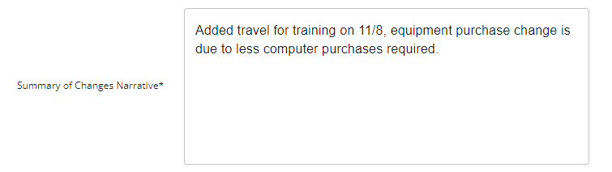

- Review the Summary of Proposed Changes. The new direct cost column should reflect what you intend your budget to be after the modification. If you need to make further edits, go back to the saved excel file, adjust as needed and re-upload excel file to the amendment.
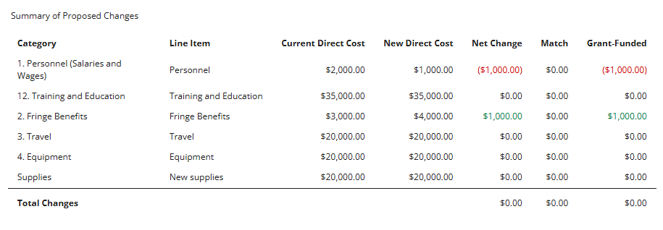

- Add a Justification and Upload File(s) required by your ICCB grant program. Multiple files may be uploaded. If you are unsure what or if any documents are required, please ask your ICCB program contact. For Perkins grants, the entire revised uniform budget is required. The justification must fully detail the new activity. A justification may be detailed in a separate file and uploaded instead of typing it into the box if you choose.


- Click Save to return and finish later or Submit to submit your finalized amendment to ICCB.


