

Application Process

For

ICCB Grantees

Table of Contents

Table of Contents 1
GATA Grantee Portal Prerequisites 1
Opportunity Details 1
Project Information and Navigation 3
Application Forms 5
Budget 5
Submit Application 10
Customer Support 11

GATA Grantee Portal Prerequisites
Applicants must register with the GATA Grantee Portal and be granted access to the Euna Applicant Portal and Euna GMS.
The following support article outlines the following processes:
- Create GATA Grantee Portal Account here - https://grants.illinois.gov/portal.
- Link the account to the appropriate Organization.
- Grant access to the Euna Applicant Portal and Euna GMS.
- Toggle between the Applicant Portal and Euna GMS.
How to Add New Users as a Grantee and Single-Sign-On (SSO) Process
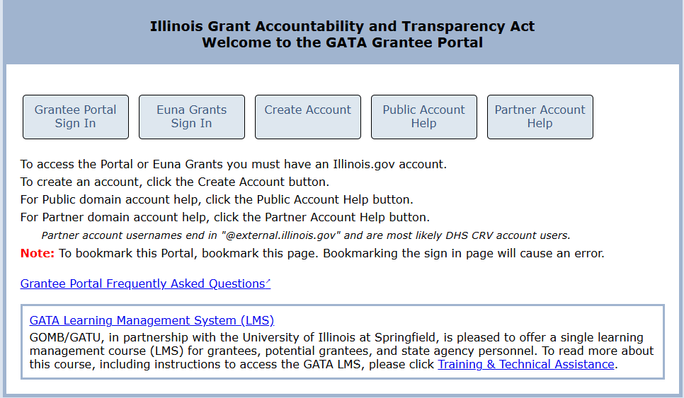

Opportunity Details
Applicants can find a link to apply on the Catalogue of State Financial Assistance (CSFA) or and on the ICCB Grant Opportunities page.
Complete the following steps to access Opportunities from the CSFA:
- Access the CSFA here - https://gata.illinois.gov/grants/csfa.html.
- Select Click here to browse a list of current funding opportunities.
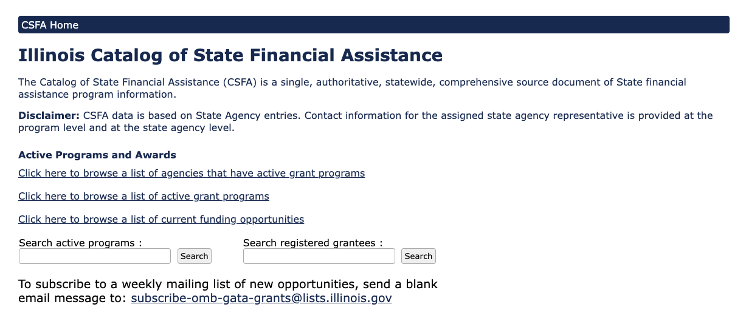
- Search for the appropriate Opportunity.
  - Anything with a green GMS sticker is published in Euna.
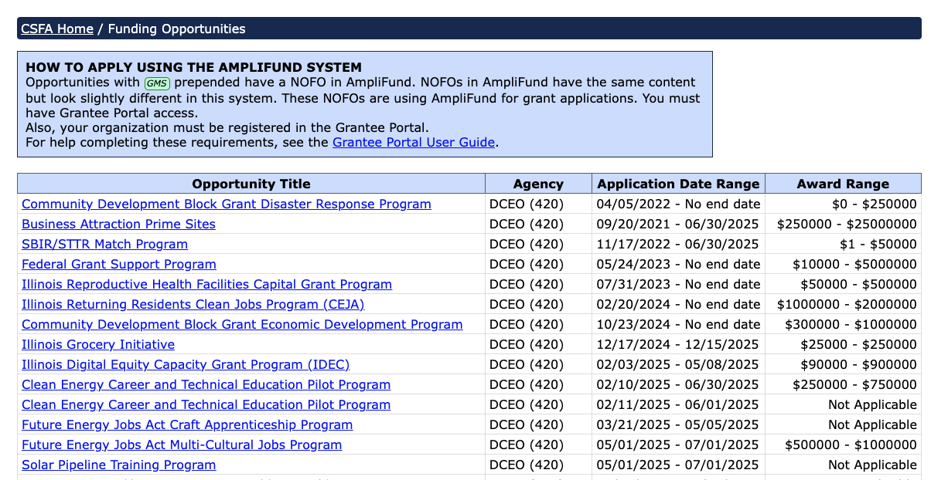
- Review the note as needed.
- Select the Opportunity Title link under Continue to the NOFO in Euna.

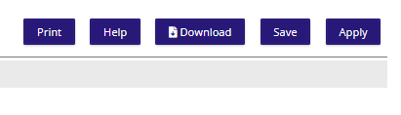
- Alternatively, use the Public Link provided by the ICCB.
- Land on the Opportunity Details page.
Complete the following steps to review the Opportunity Details:
- Review the Print, Help, Download, Save, and Apply options on the top right of the screen.
  - Use the back button on the browser to get back to the Opportunity Details page.
- Review the Opportunity Details and related attachments.
- Select Apply.
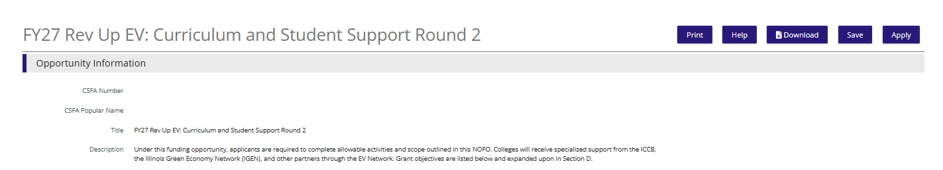
- Land on the Project Information Page.

Project Information and Navigation
Navigate throughout the Application Packet by selecting the appropriate element across the top of the screen. For example, select the Application Forms to review all the required Application Forms. Then, select the Project Information element to navigate back to the Project Information page.
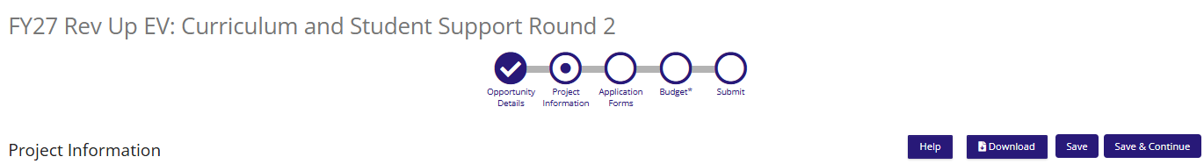
Enter basic Application Information and Primary Contact information on the Project Information page.
Complete the following fields on the Project Information page:
- Application Name.
- Award Requested.
- Leave all Match categories at $0.00.
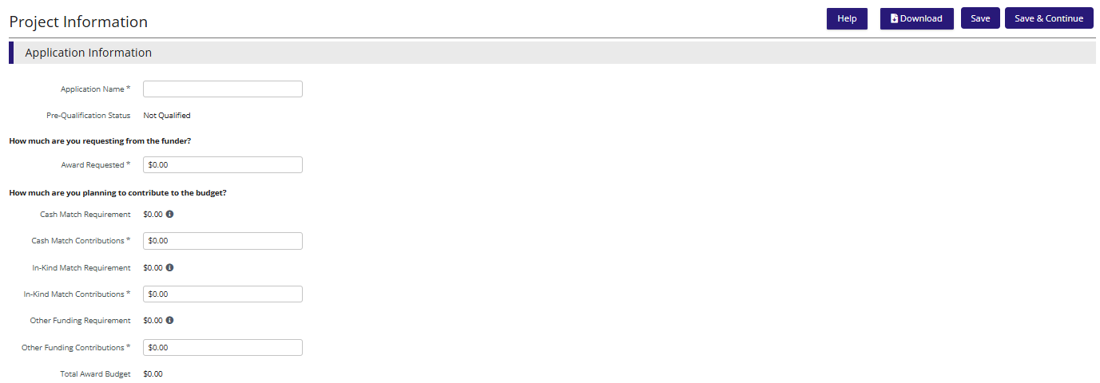
- Enter Place of Performance/Location Information.
- Enter Additional Location Information, if necessary.
- Enter Organizational Information, if required.
- Enter Primary Contact Information
- Mark as Complete.
- Click Save and Continue.
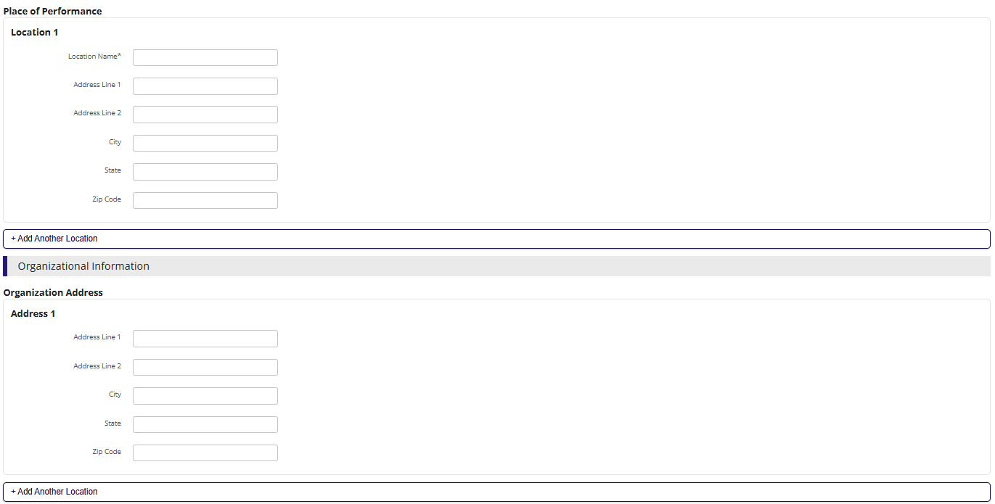
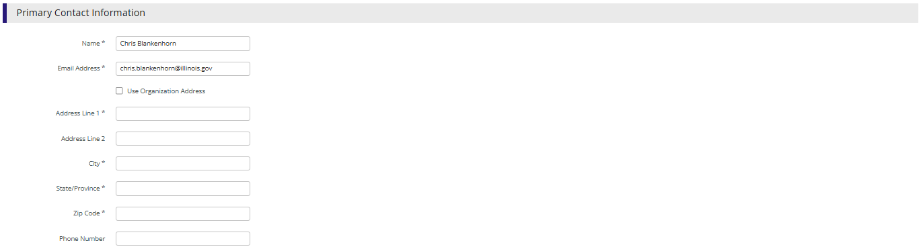
- Land on the Application Forms list page.

Application Forms
The ICCB configures Application Forms to collect information from Applicants. The Application Forms Grid shows the Name, Status, and Print options of each form. Use only the templates provided by ICCB within this section.
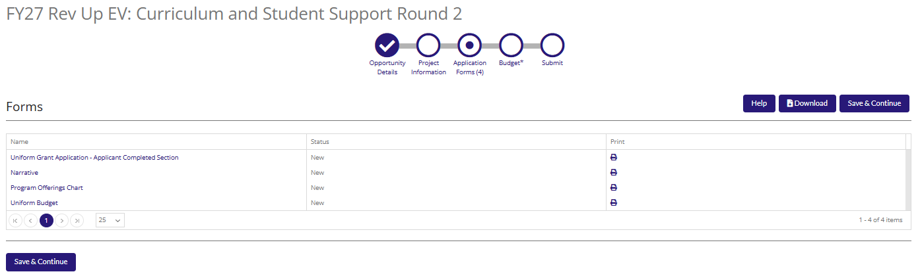
Complete the following steps for each Application Form:
- Select the Form Name to start the Application Form.
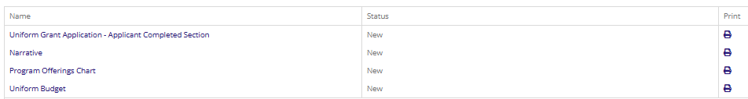
- Review all application instructions, fields, and downloadable attachments carefully.
- Complete all required fields marked with an (*).
- Complete all applicable optional fields.
- Mark as Complete.
- Click Save and Continue.
- Land on the next Application Form page.
- Complete the above steps for all Application Forms.
NOTE: Use only the documents provided in this section to complete and upload for your application! Do not use previous years’ documents as changes may have occurred. If current forms are not used, applicants may be asked to redo the form on the correct/current version.
- Land on the Budget after completing the last Application Form.

Budget
Applicants must account for all the Award Requested amount on the Project Information page when completing the Budget. For example, if requesting $50,000 on the Project Information page corresponding Line Items must be entered against allowable Budget Categories to reconcile the Award Requested with the Total Revenue Budget Cost on the Budget.
For awards managed in the State Grant Management System (Euna), two budget documents are required, 1. the GATA-covered or GATA-exempt budget template (Excel template) is submitted in the Application Forms section of the Euna application, and 2. a summary budget is entered as the Euna budget. budgets are made operational in Euna strictly at the category level; these subtotals act as the individual line items. Entering the Euna budget at the category total level streamlines post-award functionality, such as budget modifications, quarterly reporting, and payment requests, which are all completed at the category total level. Your Euna budget should match your excel budget template’s Section A.
View ICCB’s Euna Budget Instructions for a more detailed guide for entering your Euna budget.
This table can be used to complete the category level entries.
Personnel (Salaries and Wages) | Fringe Benefits | Travel
Category: 1. Personnel (Salaries and Wages)  Line Item: Personnel  Line Item Type: Direct Cost Calculation  Base: Enter the total of your Personnel category  Calculation Type: Select “Quantity x Rate”  Rate: 1%  Cost Rate: Enter the total for your Personnel category  Quantity: 1  Salary: Enter the total for your Personnel category  Grant Budgeted: Enter the total for your Personnel category  Total Budgeted (Direct Cost): Enter the total for your Personnel category | Category: 2. Fringe Benefits  Line Item: Fringe Benefits  Line Item Type: Direct Cost Calculation  Base: Enter the total of your Fringe Benefits category  Calculation Type: Select “Quantity x Rate”  Rate: 1%  Cost Rate: Enter the total for your Fringe Benefits category  Quantity: 1  Salary: Enter the total for your Fringe Benefits category  Grant Budgeted: Enter the total for your Fringe Benefits category  Total Budgeted (Direct Cost): Enter the total for your Fringe Benefits category | Category: 3. Travel  Line Item: Travel  Line Item Type: Direct Cost Calculation  Calculation Type: Select “Quantity x Rate”  Base: Enter the total of your Travel category  Rate: 1%  Cost Rate: Enter the total for your Travel category  Quantity: 1  Grant Budgeted: Enter the total for your Travel category  Total Budgeted (Direct Cost): Enter the total for your Travel category
Equipment | Supplies | Contractual Services & Subawards
Category: 4. Equipment  Line Item: Equipment  Line Item Type: Direct Cost Calculation  Calculation Type: Quantity x Rate  Base: Enter the total of your Equipment category  Rate: 1%  Cost Rate: Enter the total for your Equipment category  Quantity: 1  Grant Budgeted: Enter the total for your Equipment category  Total Budgeted (Direct Cost): Enter the total for your Equipment category | Category: 5. Supplies  Line Item: Supplies  Line Item Type: Direct Cost Calculation  Calculation Type: Quantity x Rate  Base: Enter the total of your Supplies category  Rate: 1%  Cost Rate: Enter the total for your Supplies category  Quantity: 1  Grant Budgeted: Enter the total for your Supplies category  Total Budgeted (Direct Cost): Enter the total for your Supplies category | Category: 6. Contractual Services & Subawards  Line Item: Contractual Services  Line Item Type: Direct Cost Calculation  Calculation Type: Quantity x Rate  Base: Enter the total of your Contractual Services and Subawards category  Rate: 1%  Cost Rate: Enter the total for your Contractual Services category  Quantity: 1  Grant Budgeted: Enter the total for your Contractual Services category Total Budgeted (Direct Cost): Enter the total for your Contractual Services category
Consultant Services and Expenses | Training and Education | Other or Miscellaneous Costs
Category: 7. Consultant Services and Expenses  Line Item: Consultant Services and Expenses  Line Item Type: Direct Cost Calculation  Calculation Type: Quantity x Rate  Base: Enter the total for your Consultant Services category  Rate: 1%  Cost Rate: Enter the total for your Consultant Services category  Quantity: 1  Salary: Enter the total of your Consultant Services category  Grant Budgeted: Enter the total for your Consultant Services category  Total Budgeted (Direct Cost): Enter the total for your Consultant Services category | Category: 12. Training and Education  Line Item: Training and Education  Line Item Type: Direct Cost Calculation  Calculation Type: Quantity x Rate  Base: Enter the total of your Training and Education Category  Rate: 1%  Cost Rate: Enter the total for your Training and Education category  Quantity: 1  Grant Budgeted: Enter the total for your Training and Education category  Total Budgeted (Direct Cost): Enter the total for your Training and Education category | Category: 14. Other or Miscellaneous Costs  Line Item: Other or Miscellaneous Costs  Line Item Type: Direct Cost Calculation  Calculation Type: Quantity x Rate  Base: Enter the total of your Other or Miscellaneous Costs category  Rate: 1%  Cost Rate: Enter the total for your Other or Miscellaneous Costs category  Quantity: 1  Grant Budgeted: Enter the total for your Other or Miscellaneous Costs category  Total Budgeted (Direct Cost): Enter the total for your Other or Miscellaneous Costs category
Indirect Cost | Grant Exclusive (Student Supports)
Category: Indirect Cost  Line Item: Indirect Cost  Line Item Type: Indirect Cost  Calculation Type: Quantity x Rate  Base: Enter the total of your Indirect Cost category  Rate: 1%  Cost Rate: Enter the total for your Indirect Cost category  Quantity: 1  Grant Budgeted: Enter the total for your Indirect Cost category Total Budgeted (Direct Cost): Enter the total for your Indirect Cost category | Category: 15. Grant Exclusive Line Items  Line Item: Grant Exclusive  Line Item Type: Direct Cost Calculation  Calculation Type: Quantity x Rate  Base: Enter the total of your Grant Exclusive category  Rate: 1%  Cost Rate: Enter the total for your Other or Miscellaneous Costs category  Quantity: 1  Grant Budgeted: Enter the total for your Grant Exclusive category  Total Budgeted (Direct Cost): Enter the total for your Grant Exclusive category

Complete the following steps to add Budget Line Items:
- Select the + icon next to the appropriate Budget Category.
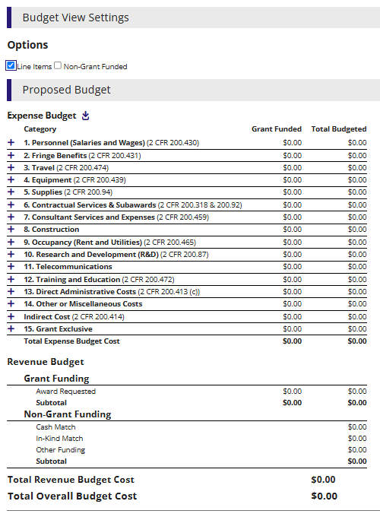
- Enter Name, this should match the category name. For example, the Line Item name for the Personnel Category should be Personnel and should be the category level total.
- Enter all required fields based on Category.
  - Because entries are at the category level, the rate, time, or other modifiers should always be set to 1 or 100% so your category total fully transfers to the budget.
- Click Create on the bottom right of the screen.
- Repeat for all Line Items.
NOTE: Not all categories are allowable for all ICCB grants, so some categories may not be available to use.
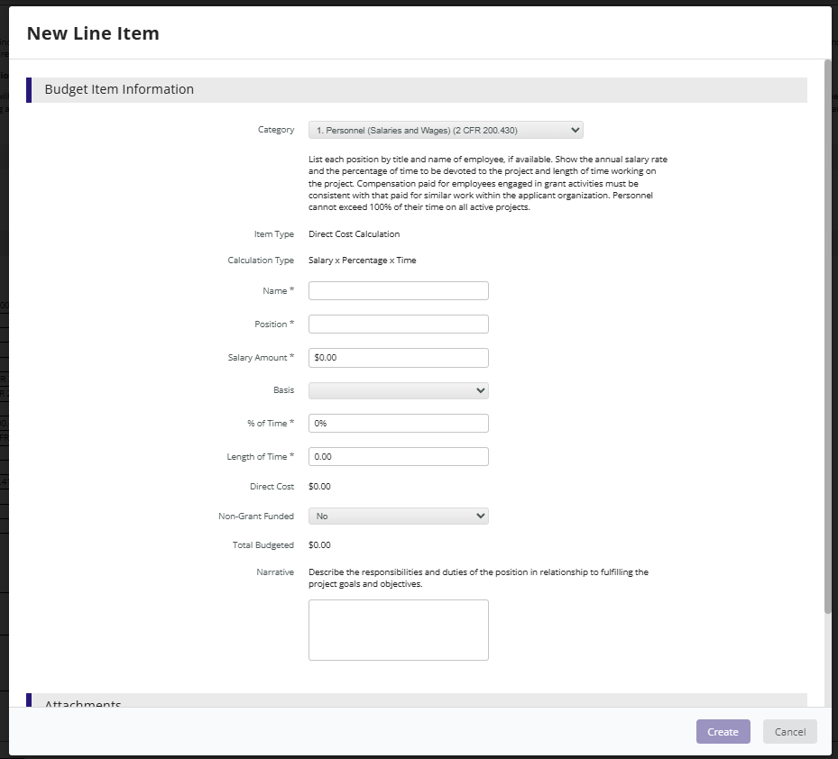
- Supporting documentation is not required, unless specified by in the grant’s NOFO.
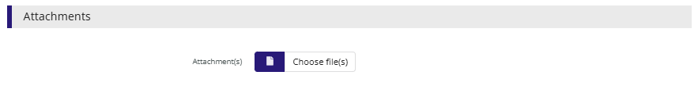
- Select the pencil icon to edit line items.
- The Total Overall Budget Cost must be $0.00.
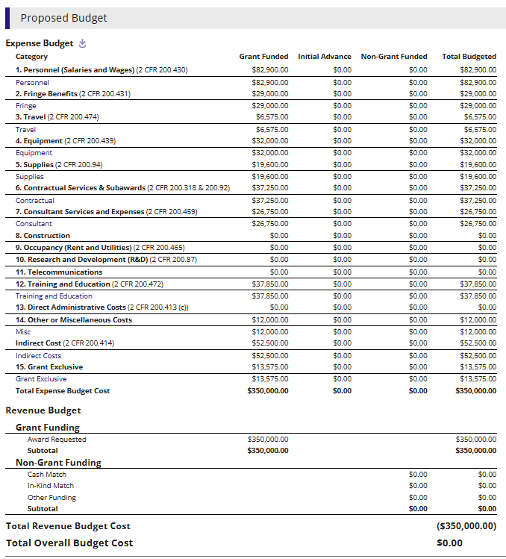
- Toggle to and update Award Requested amount on the Project Information page, then back to the Budget to reconcile as needed.
- Save progress before navigating.
- Select Mark as Complete.
- Click Save and Continue.
- Land on the Submit page.

Submit Application
The Project Information page, all Application Forms, and the Budget must be Marked as complete to submit. The navigation element will be green with a white checkmark when complete. Euna displays validation errors if there are incomplete sections in the Application Packet.
Incomplete Application:
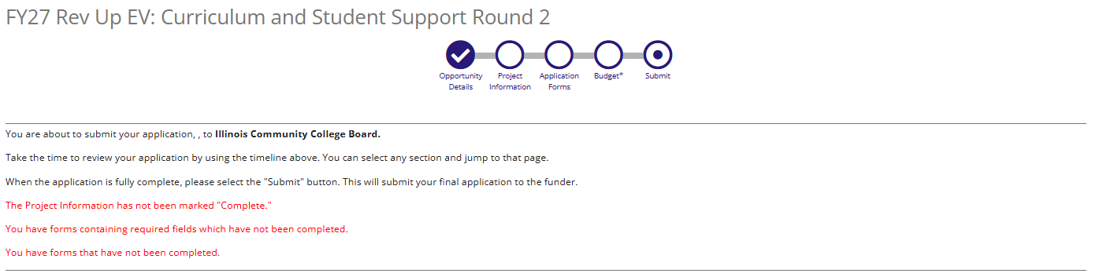
Submitted Application:
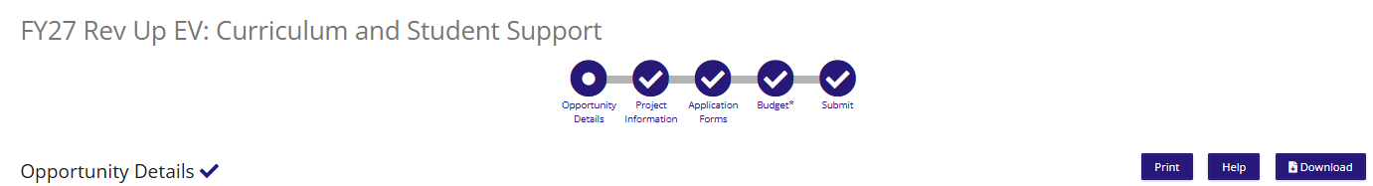

Customer Support
Euna Links:
- Production Link: https://il.amplifund.com
- Euna Grants Applicant Training Series: https://grants-help.eunasolutions.com/hc/en-us/sections/360011592053-Euna-Grants-Applicant-Series
- Access & Navigation for Grant Recipients: https://grants-help.eunasolutions.com/hc/en-us/articles/360062847113-Access-Navigation-for-Grant-Recipients
- Adding New Users to Your Recipient Account: https://grants-help.eunasolutions.com/hc/en-us/articles/1500002418221-Adding-New-Users-to-your-Recipient-Account
- Euna Grants Application Portal: Application Overview and Submission https://grants-help.eunasolutions.com/hc/en-us/articles/27453370618259-2026-07-13-Euna-Grants-Applicant-Portal-Application-Overview-and-Submission
Euna Support Contacts:
- Euna Support Site: https://il-amplifund.zendesk.com
- Euna Support Email: support@il-amplifund.zendesk.com
- Euna Support Phone: (844) 407-3573
GATA Support Contacts: - for questions about the GATA portal
- GATA Support Site: https://gata.illinois.gov
GATA Support Email: omb.gata@illinois.gov
- GATA Support Phone: (217)-782-4520

