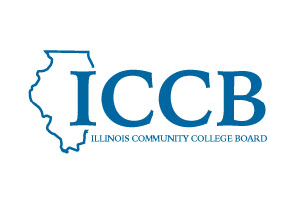
MEETING NOTICE
Student Support and Eligibility

In accordance with the Illinois Open Meetings Act, the Illinois Community College Board hereby gives notice that the Dual Credit Quality Act Committee will meet on March 6, 2026 at 1:00 pm via videoconference as permitted by Public Act 104-0012.

The Agenda and/or any other pertinent materials will be available for downloading on the website at https://www.iccb.org/divisions/academic-affairs/dual-credit/.

Please use the link on the ICCB website to join the meeting.

https://illinois.webex.com/illinois/j.php?MTID=mfe19059191fa5cd34af91b6328d87d02

Join by meeting number
Meeting number (access code): 2630 164 8411
Meeting password: T37Eiy3K2dt
Tap to join from a mobile device (attendees only)
+1-312-535-8110,,26301648411## United States Toll (Chicago)
+1-415-655-0002,,26301648411## US Toll
Join by phone
+1-312-535-8110 United States Toll (Chicago)
+1-415-655-0002 US Toll
Global call-in numbers
Join from a video system or application
Dial 26301648411@illinois.webex.com
You can also dial 173.243.2.68 and enter your meeting number

