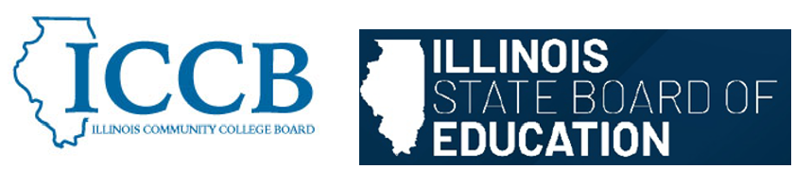

DUAL CREDIT QUALITY ACT COMMITTEE
Student Support and Eligibility

Agenda
March 6, 2026, 1:00 pm – 3:00 pm

- Welcome & Introductions

- Review Student Support and Eligibility section from the Model Partnership Agreement

- Sub-committee discussion

- Public Comment

- Adjourn

To join the meeting:

https://illinois.webex.com/illinois/j.php?MTID=mfe19059191fa5cd34af91b6328d87d02
Join by meeting number
Meeting number (access code): 2630 164 8411
Meeting password: T37Eiy3K2dt
Tap to join from a mobile device (attendees only)
+1-312-535-8110,,26301648411## United States Toll (Chicago)
+1-415-655-0002,,26301648411## US Toll
Join by phone
+1-312-535-8110 United States Toll (Chicago)
+1-415-655-0002 US Toll
Global call-in numbers
Join from a video system or application
Dial 26301648411@illinois.webex.com
You can also dial 173.243.2.68 and enter your meeting number.

