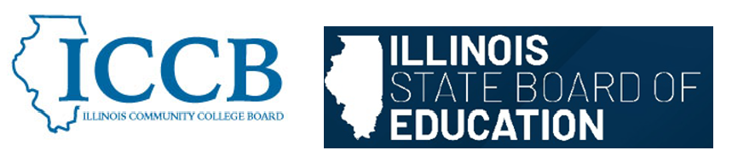

DUAL CREDIT QUALITY ACT COMMITTEE
Partnership Agreements

Agenda
March 5, 2026, 2:00 pm – 4:00 pm

- Welcome & Introductions

- Review Partnership Agreements section from the Model Partnership Agreement

- Sub-committee discussion

- Public Comment

- Adjourn

To join the meeting:
https://illinois.webex.com/illinois/j.php?MTID=m9760e2de7bdf2f08e82c1f19e8291d34
Join by meeting number
Meeting number (access code): 2634 380 4753
Meeting password: qEhibFdb883
Tap to join from a mobile device (attendees only)
+1-312-535-8110,,26343804753## United States Toll (Chicago)
+1-415-655-0002,,26343804753## US Toll
Join by phone
+1-312-535-8110 United States Toll (Chicago)
+1-415-655-0002 US Toll
Global call-in numbers
Join from a video system or application
Dial 26343804753@illinois.webex.com
You can also dial 173.243.2.68 and enter your meeting number.

