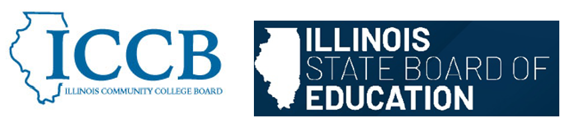

DUAL CREDIT QUALITY ACT COMMITTEE
Faculty Qualifications

Agenda
March 6, 2026, 9:00 am – 11:00 am

- Welcome & Introductions

- Review Faculty Qualifications section from the Model Partnership Agreement

- Sub-committee discussion

- Public Comment

- Adjourn

To join the meeting:
https://illinois.webex.com/illinois/j.php?MTID=m76a35bd26b6291f47ea343abee67753c
Join by meeting number
Meeting number (access code): 2861 122 4105
Meeting password: rM2c6zBuZM2
Tap to join from a mobile device (attendees only)
+1-312-535-8110,,28611224105## United States Toll (Chicago)
+1-415-655-0002,,28611224105## US Toll
Join by phone
+1-312-535-8110 United States Toll (Chicago)
+1-415-655-0002 US Toll
Global call-in numbers
Join from a video system or application
Dial 28611224105@illinois.webex.com
You can also dial 173.243.2.68 and enter your meeting number.

