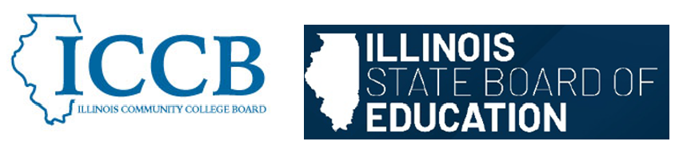

DUAL CREDIT QUALITY ACT COMMITTEE
Course Equivalency and Rigor Standards

Agenda
March 5, 2026, 11:30 am – 1:30 pm

- Welcome & Introductions

- Review Course Equivalency and Rigor Standards section from the Model Partnership Agreement

- Sub-committee discussion

- Public Comment

- Adjourn

To join the meeting:
https://illinois.webex.com/illinois/j.php?MTID=md06cb7d1804a0bf201589fea78f8e5e1

Join by meeting number
Meeting number (access code): 2634 394 6416
Meeting password: tMfS5uXHK75
Tap to join from a mobile device (attendees only)
+1-312-535-8110,,26343946416## United States Toll (Chicago)
+1-415-655-0002,,26343946416## US Toll
Join by phone
+1-312-535-8110 United States Toll (Chicago)
+1-415-655-0002 US Toll
Global call-in numbers
Join from a video system or application
Dial 26343946416@illinois.webex.com
You can also dial 173.243.2.68 and enter your meeting number.

