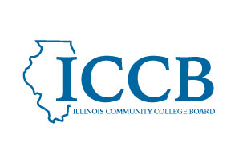

MEETING NOTICE

In accordance with the Illinois Open Meetings Act, the Illinois Community College Board hereby gives notice that the Dual Credit Quality Act Committee will meet on April 29, 2026 at 2:30 pm via videoconference as permitted by Dual Credit Quality Act P.A. 104-0012.

The Agenda and/or any other pertinent materials will be available at a later time for downloading on the website at Dual Credit - ICCB.

Please use the link on the ICCB website to join the meeting.

https://illinois.webex.com/illinois/j.php?MTID=m37dc21c7a0e3500a8b2da9cbf389afa7

