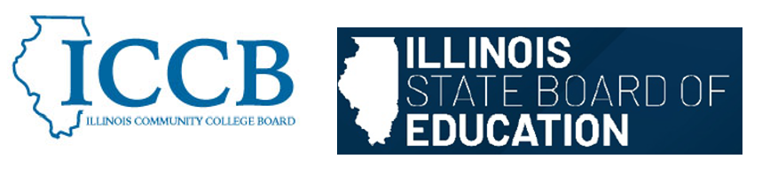
DUAL CREDIT QUALITY ACT COMMITTEE

Agenda
April 29, 2026, 2:30 pm – 4:00 pm

To join the meeting:
https://illinois.webex.com/illinois/j.php?MTID=m37dc21c7a0e3500a8b2da9cbf389afa7

- Welcome

- Housekeeping and General Business

- Approval of January minutes

- Model Partnership Agreement Sub-Committee Meeting updates and discussion of summaries

  - Course Equivalency and Rigor presentation and discussion – Dr. Scott Rowe
  - Faculty Qualifications presentation and discussion – George Evans
  - Partnership Agreements presentation and discussion – Dr. Pam Lau
  - Student Eligibility and Supports presentation and discussion – Dr. Jennifer Ivory-Tatum

- MPA Synthesis – Emily Rusca

  - Key issues
  - Helpful aspects of the MPA? Unhelpful aspects of the MPA?
  - Next steps

- Dual Credit Future Considerations/Clarifications

What are broad items that we need to consider or address in the future?

- Public Comment

- Announcements: Fall Meeting – October 2026

- Adjourn

