Activities/
Resources
for

Outcomes

Oakland students give old computers a new home

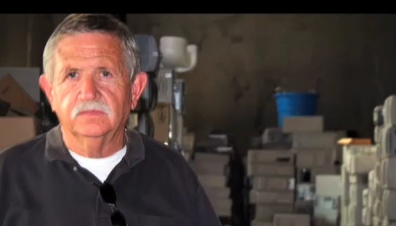
By Kate McLean Posted September 10, 2009 6:00 am
On a hot day in West Oakland, children and parents sat at rows of desks in a warehouse classroom. It was dark, the fan hummed and people chattered in low voices. A sense of expectation filled the room.
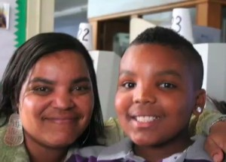
In three hours, every child would get a voucher for a free computer.
“Okay, ground rules,” said a voice from the back of the class. “Although these computers are free, you pay with your attention. No iPods or text messaging. No internet or games until the appropriate time.”
The voice belonged to 32-year-old instructor Naomi Jimenez, who runs a tight ship. She was there to teach everyone how to use the computer and the software that comes with it. The noise tapered off, and Jimenez launched into a demonstration. The countdown to a new computer had begun.
Jimenez works for Oakland Technology Exchange West, an organization with a simple mission: get unwanted computers, fix them and give them to every middle and high school student in the Oakland Unified School District.
The district doesn’t track how many of its students own computers, but most are considered low income—69 percent qualify for free or reduced school lunches. These students live in a city that threw away 1,047 tons—or 2,094,000 pounds—of e-waste last year, according to StopWaste.org, an Alameda County waste reduction organization.
E-waste includes computer monitors, flat screens, CPUs and other electronics such as portable DVD players, TVs and cell phones. E-waste contains a number of toxic materials, such as lead, which is found in cathode ray tubes from computer monitors, and mercury, which is used in flat screens, so keeping it out of the waste stream benefits the environment.
“Just turning computers into consumables that we throw away is so incredibly destructive to the planet,” said Oakland Technology Exchange West Founder Bruce Buckelew. “There couldn’t be a better synergy between two problems, e-waste and [the] digital divide. It’s like a perfect match.”
Buckelew, who is 66, is a retired IBM engineer. After volunteering to fix computers in the basement of Oakland Technical High School, he founded Oakland Technology Exchange West in 1995. Over the years, the center has grown to employ a staff of eleven, some of whom were students and clients before they graduated to working there.
The center gives away about 1,500 computers to Oakland students every year and sends another 1,000 to community groups and schools, preventing about 100 tons of e-waste annually.
This is accomplished by sorting and repairing a huge volume of donated machines. In the back of the warehouse, 6-foot-tall stacks of computers line the walls. Towering columns of monitors and CPUS divide the main room, leaving narrow walkways.
The donations arrive on the loading dock, where the light shines through a few bullet holes in a metal door. From there, they go to the volunteer area, and on an average day about 25 people sit at long tables cleaning computers, monitors and keyboards. They also test mice and speakers and remove useful parts from older computers that will be recycled.
Many of the donated computers come from local companies, which purge old machines and replace them with new ones every few years. Other computers are dropped off on donation days by people who don’t want them anymore.
“We get a lot of amazing computers that have viruses,” said Buckelew. “You know when you have a lot of money, the easier thing to do when your computer starts acting weird is buy a new one.”
The staff makes repairs in a back area full of open machines, some of which are up and running with the circuitry exposed. Every surface is littered with components, cords, wires and parts. A rack holds plastic bins of circuit boards. In some cases, Post-it notes indicate the state of the various fix-it jobs. “Done, put back together” read one note.
This is the domain of technical support specialist Dan Huynh, who started working on computers with Buckelew in 1994 when he was in 10th grade. Huynh and other staff members take the computers apart, replace whatever needs replacing, erase the hard disks to remove old files and viruses, and install the software that the center provides.
Many of the center’s clients come from West Oakland, but any 6th to 12th grade student in the district can participate. To alert families, the staff sends flyers and emails to Oakland middle and high schools at the start of the school year, and they bring a booth to registration days.
To get a computer, students must take the three-hour class, offered in English or Spanish, and bring a parent. Then they receive a PC with a Pentium III processor, a monitor, a mouse and a keyboard. If they want a faster machine with a bigger hard drive, they can volunteer to earn “service bucks,” which can be used like cash at the center’s “Tech Store.” Parents and community members can also volunteer to earn computers.
Back in the classroom, Robert Malone, a 28-year-old counselor, was sitting in a corner with three shy teenage boys from an Oakland group home. “Whenever we get new residents, I like to bring them here so that they can have computers,” he said. “Being computer literate is important. We want to make sure that they will be well-versed in as many skills as possible.”
17-year-old Adrian, a young man with slicked-back hair and a soft voice, was looking forward to using his machine for games, email, and homework. Ra’sheed, a round-faced 14-year-old, wanted to use his computer to loop beats and make music with Audacity, the audio editing program that the center offers.
Next to Ra’sheed sat Tim, a 17-year-old with the hint of a mustache on his upper lip. He was polite but wary.
“I like to type,” he said, without making eye contact.
Did he mean he liked to write?
“Yes.”
What kind of thing did like to write?
“Poems,” he said, looking up and holding his gaze steady.
About an hour later, Jimenez led Tim and the other students through a word processing demonstration using Open Office, a free office software suite. She directed the students to open a new document and type their name and why they had come to the class.
Tim typed: “I am here to get a new computer for school.”
From the back of the class, Jimenez explained how to change the font.
Tim changed his text to cursive. He made his name blue and his text red. He hit delete and tapped a few keys. A small smile crossed his face.
His screen now read, “I am here to get a new computer for writing.”

From: http://oaklandnorth.net/2009/09/10/computers/

Outcome #6

The Hippocratic Oath

[Original, translated from ancient Greek]

I swear by Apollo, Asclepius, Hygieia, and Panacea, and I take to witness all the gods, all the goddesses, to keep according to my ability and my judgment, the following Oath:

To consider dear to me, as my parents, him who taught me this art; to live in common with him and, if necessary, to share my goods with him;

To look upon his children as my own brothers, to teach them this art I will prescribe regimens for the good of my patients according to my ability and my judgment and never do harm to anyone.

To please no one will I prescribe a deadly drug nor give advice which may cause his death. But I will preserve the purity of my life and my arts.

I will not cut for stone, even for patients in whom the disease is manifest; I will leave this operation to be performed by practitioners, specialists in this art.

All that may come to my knowledge in the exercise of my profession or in daily commerce with men, which ought not to be spread abroad, I will keep secret and will never reveal.

If I keep this oath faithfully, may I enjoy my life and practice my art, respected by all men and in all times; but if I swerve from it or violate it, may the reverse be my lot.

Outcome #6
Medical Research Graphic Organizer

Medical Career | Description of Career | Education & Training Required | Salary

Outcome #7

Hammurabi's Code

Study these laws taken from the Code of Hammurabi, and then answer the questions below.

1. If a person accuses another person of a crime, the accused shall go to the river and jump in. If he drowns, the person who accused him may have the accused person's house. If the accused doesn't drown, then the River-God has decided that he is innocent. The person who made the accusation is to be put to death, and the accused shall take his house.
2. If anyone opens his ditches to water his crop, but is careless, and the water floods the field of his neighbor, then he shall pay his neighbor corn for his loss.
3. If he be not able to replace the corn, then he and his possessions shall be divided among the farmers whose corn he has flooded.
4. If a physician kills a patient or cuts out a patient's eye when trying to remove a tumor, the physicians' hands will be cut off.
5. If a builder builds a house and the house collapses and kills the owner of the house, the builder shall be put to death. If the house collapses and kills the owner's son, then the son of the builder shall be put to death.
6. If a son hits his father, his hands shall be cut off.
7. If a fire breaks out in a house and a person who helps to put out the fire steals something from the house, that person shall be thrown into the fire.
8. If a man destroys the eye of another man, his eye shall be destroyed. If he breaks the bone of another, his bone shall be broken.
9. If a man's wife, who lives in his house, wishes to leave it, plunges into debt, tries to ruin her house, neglects her husband, and is found guilty: if her husband offer her release, she may go on her way, and he gives her nothing as a gift of release. If her husband does not wish to release her, and if he take another wife, she shall remain as a servant in her husband's house.
10. If a man wishes to divorce his wife, he must return her dowry and give her the use of part of his field for farming and part of his property so that she can provide for her children.
11. If a man's wife becomes sick, the husband may take a second wife, but must continue to care for the sick wife as long as she lives.
12. If a person steals from a temple or takes goods stolen from the temple, he shall be put to death.

Based on these laws, what can we learn about Babylonian society? Record your answers below.

Religion: ____________________________________________________________________ ____________________________________________________________________________ ____________________________________________________________________________ ____________________________________________________________________________ ____________________________________________________________________________
Marriage: ____________________________________________________________________ ____________________________________________________________________________ ____________________________________________________________________________ ____________________________________________________________________________ ____________________________________________________________________________ ____________________________________________________________________________ Making a living: _______________________________________________________________ ____________________________________________________________________________ ____________________________________________________________________________ ____________________________________________________________________________ ____________________________________________________________________________ ____________________________________________________________________________ Other aspects of Babylonian society: ______________________________________________ ____________________________________________________________________________ ____________________________________________________________________________ ____________________________________________________________________________ ____________________________________________________________________________ ____________________________________________________________________________ ____________________________________________________________________________
Outcome #8

Mali Project Presentation

1. Mali improvement project name: _________________________________________________
Group members: ____________________________________________________________________________ ________________________________________________________________________________________________________________________________________________________________________________________________________________________________________________________________________________________________________________ 2. How will you explain your group's proposal to the class? ____________________________________________________________________________________________________________________________________________________________________________________________________________________________________________________________________________________________________________________________________________________________________________________________
3. Explain the benefits of this proposal for the people of Mali. ________________________________________________________________________________________________________________________________________________________________________________________________________________________________________________________________________________________________________________________________________________________________________________________________________________________________________________________________________4. What are some possible objections to this proposal? How would you answer those objections? ________________________________________________________________________________________________________________________________________________________________________________________________________________________________________________________________________________________________________________ ________________________________________________________________________________________________________________________________________________________

5. Concluding Statement: This is your last opportunity to convince the class that your project is the best plan for improving the lives of people in Mali. ____________________________________________________________________________________________________________________________________________________________________________________________________________________________________________________________________________________________________________________________________________________________________________________________ ____________________________________________________________________________

Outcome #9

Filmmaking Career Match-Up

- _____ Actor  - _____ Associate producer  - _____ Best boy grip  - _____ Assistant director  - _____ Camera operator  - _____ Casting director  - _____ Costume designer  - _____ Director  - _____ Prop master  - _____ Executive producer  - _____ Gaffer  - _____ Key costumer  - _____ Key grip  - _____ Photography director  - _____ Producer  - _____ Production designer  - _____ Script supervisor  - _____ Set designer  - _____ Set decorator  - _____ Show runner | - Oversees the construction of the sets.  - Responsible for all financial aspects of a show.  - Writing executive producer who hires the writing team  - Operates the camera.  - Runs the set and is responsible for keeping the director on course with the production day.  - Responsible for care of wardrobe.  - Manages every aspect of a show.  - Deals with scheduling the production, hiring crew, and ordering equipment.  - Decorates with furniture, drapes, textures, etc.  - Translates the screenplay into moving images.  - Assumes character and performs role in script.  - Maintains an accurate shooting script and records in detail all information related to take.  - Responsible for directing the actors.  - Finds, auditions, and negotiates for the services of actors.  - Supervises transporting cameras, rigging, and scaffolding.  - Supervises the search of locations and designs sets.  - Responsible for lighting.  - Researches and designs all costumes.  - Maintains all props.  - Assists the key grip in taking care of equipment.

Key for Filmmaking Career Match-Up

- __K__ Actor  - __H__ Associate producer  - __T__ Best boy grip  - __E__ Assistant director  - __D__ Camera operator  - __N__ Casting director  - __R__ Costume designer  - __M__ Director  - __S__ Prop master  - __G__ Executive producer  - __Q__ Gaffer  - __F__ Key costumer  - __O__ Key grip  - __J__ Photography director  - __B__ Producer  - __P__ Production designer  - __L__ Script supervisor  - __A__ Set designer  - __I__ Set decorator  - __C__ Show runner | A. Oversees the construction of the sets.  B .Responsible for all financial aspects of a show.  - Writing executive producer who hires the writing team  - Operates the camera.  - Runs the set and is responsible for keeping the director on course with the production day.  - Responsible for care of wardrobe.  - Manages every aspect of a show.  - Deals with scheduling the production, hiring crew, and ordering equipment.  - Decorates with furniture, drapes, textures, etc.  - Translates the screenplay into moving images.  - Assumes character and performs role in script.  - Maintains an accurate shooting script and records in detail all information related to take.  - Responsible for directing the actors.  - Finds, auditions, and negotiates for the services of actors.  - Supervises transporting cameras, rigging, and scaffolding.  - Supervises the search of locations and designs sets.  - Responsible for lighting.  - Researches and designs all costumes.  - Maintains all props.  - Assists the key grip in taking care of equipment.

Outcome #9

Trailer Production Planning Worksheet

You are a filmmaking agency that specializes in creating trailers to advertise upcoming movies. The trailer you must create is for a movie called The Life of Gandhi.

Research Gandhi's life and describe three scenes you would include to attract audiences. Explain why your team made this choice.

• Scene one:

Why would this scene appeal to an audience?

• Scene two:

Why would this scene appeal to an audience?

• Scene three:

Why would this scene appeal to an audience?
Outcome #10 Biographies

William J. Powell
There is a better job and a better future in aviation for Negroes than in any other industry, and the reason is this: aviation is just beginning its period of growth, and if we get into it now, while it is still uncrowded, we can grow as aviation grows.
—William J. Powell, Black Wings

Born in 1897, William J. Powell earned an engineering degree from the University of Illinois. In 1917 he enlisted in officer training school and served in a segregated unit during World War I. During the war, Powell was gassed by the enemy, and he suffered health problems throughout his life.

After the war, Powell opened service stations in Chicago. He became interested in aviation, but the only school that would train him was located in Los Angeles. He sold his businesses in Chicago and moved to the West Coast. After learning to fly, Powell dreamed of opening an all-black flight school.

By the 1930s Los Angeles had become an important center for black aviation. Powell organized the Bessie Coleman Aero Club to promote aviation awareness in the black community. On Labor Day 1931, the flying club sponsored the first all-black air show held in the United States, an event that attracted an estimated fifteen thousand spectators. Through the efforts of the Bessie Coleman School, the number of black aviators increased dramatically despite the economic hardships of the Great Depression.

William Powell used many methods to attract African Americans to the field of aviation. He made a film about a young man who wanted to be a flyer, and for two years he published the Craftsmen Aero-News, a monthly journal about black aviation. He offered scholarships with free technical training in aeronautics for black youth. He invited celebrities, such as jazz musician Duke Ellington and boxer Joe Louis, to lend their names—and their funds—to his cause.

Powell published Black Wings in 1934. Dedicated to Bessie Coleman, the book entreated black men and women “to fill the air with black wings.” A visionary supporter of aviation, Powell urged black youth to carve out their own destiny—to become pilots, aircraft designers, and business leaders in the field of aviation.
William J. Powell
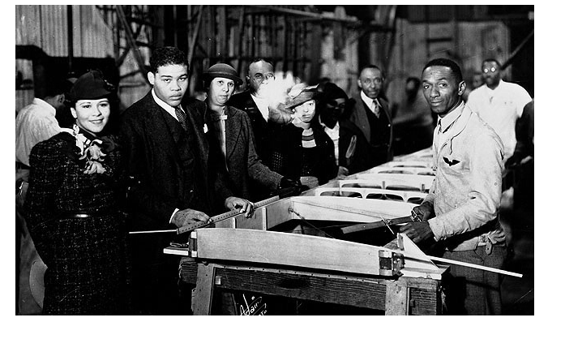
Heavyweight boxing champion Joe Louis (second from left) visits the workshop of the Bessie Coleman Aero Club in Los Angeles. William J. Powell (right) founded the club to promote aviation in the black community.

Credit: National Air and Space Museum, Smithsonian
https://airandspace.si.edu/multimedia-gallery/99-15418640jpg

Outcome #10 Biographies

C. Alfred “Chief ” Anderson
She told me, “I always heard Negroes couldn’t fly and I wondered if you’d mind taking me up.” All her escorts got tremendously upset and told her she shouldn’t do it. . . . When we came back, she said, “Well, you can fly all right.” I’m positive that when she went home, she said, “Franklin, I flew with those boys down there, and you’re going to have to do something about it.”
—C. Alfred Anderson, A-Train: Memoirs of a Tuskegee Airman

C. Alfred “Chief ” Anderson is often called the “Father of Black Aviation,” because he spent at least six decades training and mentoring countless African American aviators. Interested in flying from a young age, he saved enough money by the time he was twenty to take flying lessons, but could not find a school that would accept a black student. With his savings and some borrowed money, he bought his own plane and begged for lessons from any pilot who would listen. He finally found an instructor in Ernest Buehl, a German World War I pilot who had immigrated to the United States. Anderson earned his Private Pilot Certificate in 1929, and in 1932 he became the first black to receive his Transport License. He became friends with Dr. Albert E. Forsythe and taught Forsythe to fly. Together, in 1934, they were the first black pilots to make a round-trip continental flight.

In 1939 Anderson initiated the Civilian Pilot Training (CPT) program at Howard University. Soon he was hired to be the first African American pilot instructor at Tuskegee Institute in Alabama, which had the largest CPT program for blacks.

He was an inspiring instructor. Although many thought it couldn’t be done, “Chief ” created expert pilots at Tuskegee. As the chief civilian flight instructor at Tuskegee, Anderson trained Benjamin O. Davis, Jr., and Daniel “Chappie” James. He was known and loved by the thousands of pilots he trained during his fifty-three years as an instructor.

The most famous photograph of “Chief ” Anderson shows him smiling from the cockpit of his plane, as a beaming Eleanor Roosevelt sits behind him. The photograph was taken in 1941 during Mrs. Roosevelt’s fact-finding trip to Tuskegee. As First Lady, Mrs. Roosevelt did much to promote the cause of equal opportunity for black Americans. Over the Secret Service’s objections, she flew with Anderson to show her support for the Tuskegee program. According to Anderson, the Army Air Corps began training blacks several days after Mrs. Roosevelt’s flight.

C. Alfred “Chief” Anderson
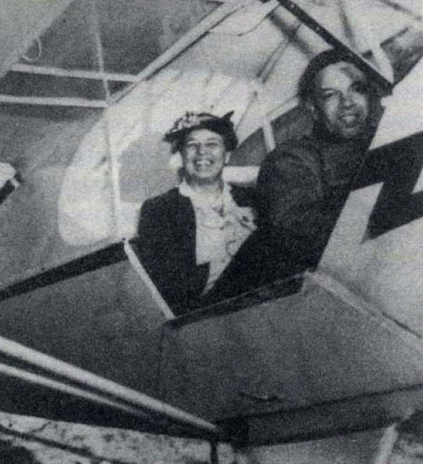

As First Lady, Eleanor Roosevelt took a special interest in the Tuskegee flight program. On a visit to the flying school, she joined C. Alfred “Chief” Anderson on an airplane ride over the facility. Her willingness to fly with a black pilot had symbolic value for the entire Tuskegee program.
Credit: National Air and Space Museum, Smithsonian Institution Date: 1941
http://pioneersofflight.si.edu/content/first-lady-eleanor-roosevelt-and-flight-instructor-c-alfred-%E2%80%9Cchief%E2%80%9D-anderson

Outcome #10 Biographies

Benjamin O. Davis, Jr.
The privileges of being an American belong to those brave enough to fight for them.
—Benjamin O. Davis, Jr.

In 1936 Benjamin O. Davis, Jr., became the first black student to graduate from West Point in the twentieth century. He graduated 35th in a class of 276 students. While at West Point, he was officially “silenced” by his classmates: No one spoke to him for four years except in the line of duty. Davis remembers, “When we traveled to football games on buses or trains, I had a seat to myself.… I lived alone in whatever quarters were provided.… Except for tutoring some underclassmen . . .I had no conversations with other cadets.”

Cadets use silencing to punish a classmate who is guilty of wrongdoing. Benjamin Davis was guilty of nothing but being black. “It was designed to make me buckle, but I refused to buckle. They didn’t understand that I was going to stay there, and I was going to graduate. I was not missing anything by not associating with them. They were missing a great deal by not knowing me.”

When Davis graduated he applied for pilot training but was turned down because there were no black units in the Army Air Corps to which he could be assigned. While he was serving in the infantry in 1940, this policy was reconsidered, and Davis was sent to Tuskegee for pilot training. Because of the war and his ability, he was quickly promoted to lieutenant colonel and commanded the 99th Fighter Squadron in combat. After one year with this all-black unit in Italy, Davis was promoted to colonel and asked to lead the 322d Fighter Group. Under Davis’s superb leadership, the Tuskegee Airmen earned the highest reputation, among both Allied and enemy pilots, for their achievements as fighter escort pilots. While under the protection of Davis’s fighter escort unit, not one bomber was ever lost to the enemy.

In 1948 President Truman’s Executive Order 9981 ended segregation in the services, and Benjamin O. Davis, Jr., continued his life of accomplishments. Davis became the first black general in the U.S. Air Force in 1954. He was the first black man to command an Army air base and the first to become a lieutenant general. Following duty in Korea, General Davis was assigned as chief of staff for the United Nations Command and the U.S. Forces in Korea. In 1967, he assumed command of the Thirteenth Air Force. General Davis retired in 1970. In 1975, President Ford appointed him Assistant Secretary of Transportation. In 1999 President Clinton advanced him to the rank of four-star general. The Tuskegee Airmen who served under Davis remember him as stern but inspiring. One said that Davis was “the most positive commander I ever had. He stressed the awful price of failure.” Another said, “Davis was respected by most and hated by some, but it was because of the discipline he exacted that we were able to make the record we did.”
Benjamin O. Davis, Jr.
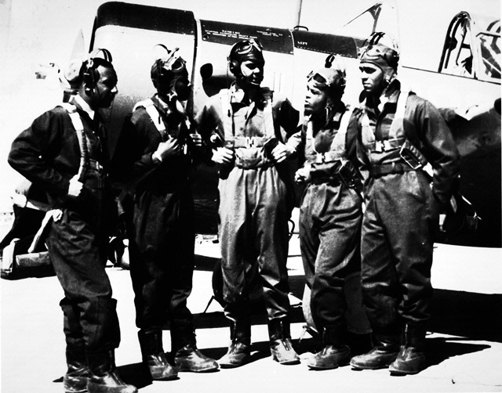

In 1941, the first group of black cadets to earn their wings at Tuskegee Army Air Field gather alongside a Vultee BT-13 trainer. Benjamin Davis Jr. (middle) became the first black general in the U.S. Air Force in 1954.
Left to right: Lemuel R. Custis, Mac Ross, Benjamin Davis, George S. Robers, Charles H. DeBow)

Credit: National Air and Space Museum, Smithsonian Institution
https://airandspace.si.edu/multimedia-gallery/99-15437640jpg?id=2993

Outcome #10
Overcoming Obstacles Worksheet
Aviator | Obstacles To Participating In Aviation |  | How Did African American Aviators Overcome The Obstacles They Faced?
William J. Powell | 1.  2. |  | 1.  2.
C. Alfred “Chief” Anderson | 1.  2. |  | 1.  2.
Benjamin O. Davis, Jr. | 1.  2. |  | 1.  2.

Outcome #11

Archaeological Thinking

Group Name:__________________________________

Artifact Bag Number: ____________________________

Directions: Use this worksheet to record your observations of the artifacts provided by your teacher.

Object | Material it is made of: | What it was used for (function):

