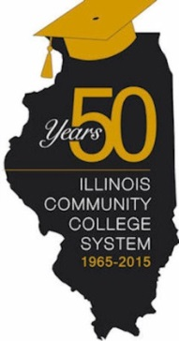

Illinois High School Equivalency Certificates Order Form

Quantity | Item
Illinois Community College Board High School Equivalency Certificates
(300 maximum order)

Ordering Agency
Regional Office of Education |  |  |  | #
Attention:
Street Address:
City, State, Zip Code:

Comments or Delivery Directions

Order Requested by: Date Requested:

Completed form may be faxed to 217-558-6700 or emailed to ilhseiccb@iccb.state.il.us.

ICCB USE ONLY
Received: | Completed:
Completed by: | Comments:

