PROJECT GUIDELINES

SCOPE
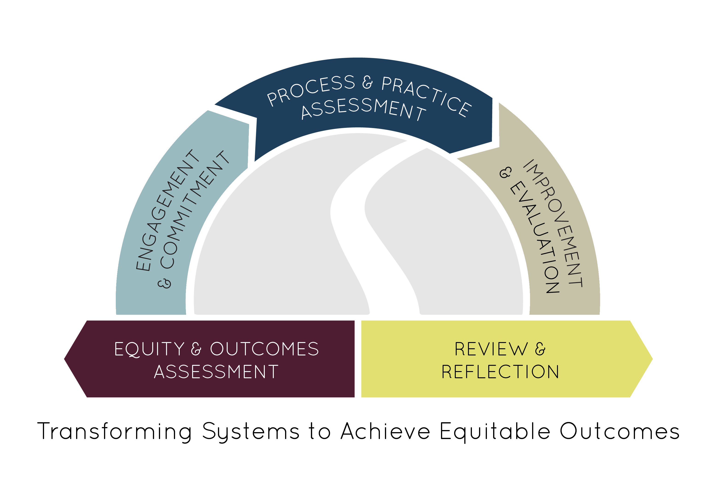
The Pathways to Results (PTR) year one project, Partnership and Planning for Student Success, aims to assemble a meaningful plan for implementing an evidence-based improvement that addresses documented gaps in students’ equitable outcomes. Different than in years past, teams’ PTR work will be concentrated through participation in an intensive two-day institute requiring both pre-work and follow-up conference calls to prepare for the final deliverable—an intervention plan that is eligible to be considered for a Year Two PTR grant that supports implementation and scaling. This project will support teams interested in improving educational outcomes and student transition to and through a pathway and programs of study including:
- Develop an engaged stakeholder group and representative team inclusive of faculty, student affairs, and academic affairs leaders, in addition to secondary and industry partners.
- Use student-level data (quantitative and qualitative) to identify outcomes gaps and create a targeted, evidence-driven vision for improving equity in the pathway.
- Analyze core processes (e.g., recruiting, advising, teaching, learning) and student support practices (e.g. first year experiences, college success courses, intrusive advising) that contribute to the identified issue.
- Propose a potential improvement or improvements for implementation.

More information on the Pathways to Results continuous improvement process is available at: http://occrl.illinois.edu/projects/pathways/.

Because of potential delays caused by increased pre-application requirements, the ICCB is releasing this opportunity early with an anticipated start date of July 1, 2017. However, availability is contingent upon federal funds and Authorization from the General Assembly. Start dates will be adjusted if necessary.

OBJECTIVES

Colleges are required to select one of the following focus areas:

- Perkins Deficient Performance Measure: PTR teams will start to address a deficient Perkins measure by gathering and analyzing data pertaining to low performing subgroups, with a special interest in underserved student groups.
- Retention and Completion: PTR teams will examine significant issues of retention and completion in pathways and programs of study. Teams may also consider projects that examine retention in more than one pathway to identify larger trends or issues.
- Program Review: PTR teams will apply the processes of PTR to program review or other institutionalized continuous improvement processes.
- Transfer Pathways: PTR teams will examine outcomes relative to student transfer to related four-year programs.
- Adult Career Pathways: PTR teams will attempt to transform pathways for adult learners to and through completion of a pathway and credentials.
- Secondary to Postsecondary Transitions: PTR teams will attempt to transform pathways for students from high school into the community college.
- Minority-Serving Institution Pathways: PTR teams will assist two-year MSIs transform CTE/STEM pathways for students from the community college to four-year institutions.
- Evaluation of Existing High-Impact Practices: PTR teams will attempt to integrate evidence based high-impact practices that help to promote student learning and engagement particularly for special populations and those who are from under-served communities.

DELIVERABLES

I. All core members of the partnership team MUST participate in the following deliverables. Meetings and webinars will be scheduled with advanced notice to participants.
- Engage stakeholders representative of faculty, student affairs, and academic affairs leaders, plus secondary and industry partners.
- Participate in one pre-institute webinar to prepare for the institute.
- Attend the Pathways to Results Intensive Institute (date TBD) to complete the Engagement and Commitment, Equity & Outcomes Assessment, and Process and Practice Assessment processes on site.
- Participate in three follow-up and planning calls with OCCRL to support final planning and data collection processes.

II. A final, brief project profile and a plan for the team to implement a pathway improvement must be created. This plan may be used as an application to receive year two, implementation funding (subject to funding and availability).

III. Midterm and Final narrative reports are to be submitted to cte@iccb.state.il.us.

TECHNICAL ASSISTANCE
ICCB CTE and OCCRL staff will provide regular technical assistance during the grant period.

FUNDING SOURCE & PERIOD
This grant is provided through Illinois Community College Board Perkins (Title I) Leadership funds. Reimbursement of up to $5,000 for travel and meetings will be facilitated through OCCRL.
Funding Period: July 1, 2017 - June 30, 2018
How to Apply: All applications should be submitted to cte@iccb.state.il.us by 5 p.m. June 23, 2017.

GRANT PROPOSAL
COLLEGE:

Primary Contact
Name/Title
Telephone/Email
Focus
Please select your focus. You must choose only one focus area.
☐ |  | Perkins Deficient Performance Measure  ☐1P1 Technical Skill Attainment  ☐2P1 Credential, Certificate, or Degree Completion  ☐3P1 Retention or Transfer  ☐4P1 Student Placement  ☐5P1 Nontraditional Participation  ☐5P2 Nontraditional Completion
☐ |  | Retention
☐ |  | Program Review
☐ |  | Transfer Pathways
☐ |  | Adult Career Pathways
☐ |  | Secondary to Postsecondary Transitions
☐ |  | Minority-Serving Institutions Pathways
☐ |  | Evaluation of Existing High-Impact Practices
Narrative
Complete the following sections.
Partnership Team
Please provide names and titles for all individuals participating on the partnership team.
Rationale
Explain why you selected the particular focus area.
Problem Statement
In no more than three sentences, identify the areas in which there is a problem or an opportunity for improvement. (If you selected program review, explain how you envision the PTR process will be incorporated into and compliment your existing review process.)
Pathways
List any pathways that would be examined and/or affected.
Prior Experience
Please explain what your prior experience has been with the PTR process.
Student Population
Please describe your college’s interest, if any, in addressing issues affecting a particular student subgroup. For example, improving pathways and outcomes for underserved student groups or a particular special population.

