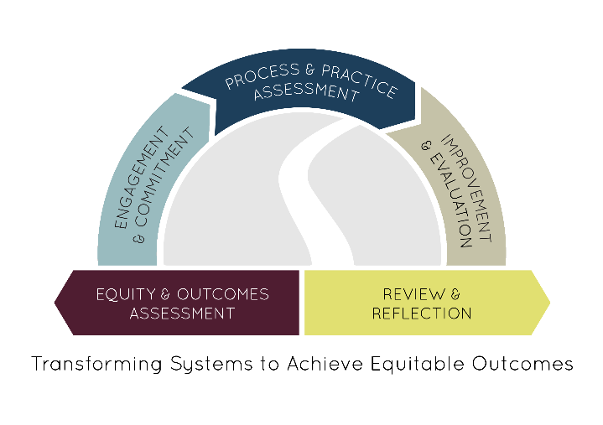

This template can be completed by any team participating in a FY 2016 or FY 2017 Pathways to Results: Planning and Inquiry (Year 1) project in order to be considered for selection to participate as a Pathways to Results: Implementation Communities (Year 2) project in FY 2018. This template may also be used for framing your own scope of implementation work, regardless of interest or intent to participate in a later round of implementation work. Because of potential delays caused by increased pre-application requirements, the ICCB is releasing this opportunity early with an anticipated start date of July 1, 2017. However, availability is contingent upon federal funds and Authorization from the General Assembly. Start dates will be adjusted if necessary.

All applications should be submitted to cte@iccb.state.il.us by 5 p.m. June 23, 2017.
College
Team Leader Name and Title
Phone/Email
Pathway(s)/Program(s) Examined
Final Problem Statement
Proposal
Summary of Findings
Summarize the findings from your 2017 PTR project that specifically inform this implementation project. Include descriptions of your findings from both Outcomes & Equity and Process & Practice Assessment, with particular attention to identifying specific equity gaps or student populations that will receive attention as a result of your data.
Expected Leadership
From your team or larger partnership, please list individuals who are committed to continue substantively with the work. You may also speculate on individuals or groups you would like to add to your core team based on your specific improvement plan.
Proposed Activities and Expected Impact
Describe the solution you intend to implement and include the expected impact on your pathway and/or student outcomes. If you have any references to research or evidence in support of these practices, please include them at the end (not required, not included in word count).
Context for Support
Describe any ongoing institutional initiatives or efforts that will support or contribute to the goals of your project.
Justification for Seeking Additional Support
Briefly describe how additional resources (should they be made available) would help your team go above and beyond the level of implementation you will attempt if external resources are not received. How could such investment increase student-level impact?
Expected Benefit to Similar Pathways or Other Student Populations
What do you think other leaders or colleges might be able to learn from your project? Who might benefit? E.g., similar pathways, student populations.
Delimitations
What are the boundaries of this project— are there issues you identified or know about but know you do not intend to address in the course of this project? (optional)
BUDGET

COMMUNITY COLLEGE |  |  |  | Amount Requested |  | Maximum Amount | $15,000
PRIMARY GRANT CONTACT
Name/Title
Telephone/Email
Budget Category | Amount |  | Description
Travel
Supplies
Contractual Services
Training & Education (MEETING)
Other*
Indirect Costs/General Admin (Limited to 5%)
TOTAL
*Requires written approval from the ICCB. Attach a description as necessary.

Budget Modifications- Grantees are allowed to make modifications up to ten percent (10%) of their total allocation, less a major change in scope, prior to seeking approval. Modifications that require a major change in scope or are greater than ten percent (10%) of their total allocation require the submission of a budget modification request (2 CFR 200.308). All requests regarding budget modifications should be submitted to: cte@iccb.state.il.us.
By submitting this report, I certify to the best of my knowledge and belief that the report is true, complete, and accurate, and the expenditures and disbursements made with these funds are for the purposes and objectives set forth in the terms and conditions of the applicable Federal or State award or program participation agreement. I am aware that any false, fictitious, or fraudulent information, or the omission of any material fact, may subject me to criminal, civil or administrative penalties for fraud, false statements, false claims or otherwise. (2 C.F.R. 200.41)
_____________________________________________ ___________________________
Signature Date

